**MAIN HEADERS FOR WEBSITE:**

**HOME**

**ABOUT SDG CAMPUS CLUB**

**ABOUT SDGs**

**SDG INTERNATIONAL FILM FESTIVAL**

**WEBINARS AND EXPERT TALKS**

**PARTNERS**

**FAQ & CONTACT**

1. Home

**SECTION 1) ABOUT SDGs**

**Webinars & Expert Talks**

**Get a chance to attend the pre and post festival webinars and expert talks on registering for the film festival.**

**International Networking**

**Be the part of a diverse community of change driven college students and working professionals. Opportunities for collaborative projects and cross cultural exchange during the festival.**

**Documentary Screening**

**Enjoy an exclusive screening of our selected award winning documentaries and short films throughout the 2 days and interact with the Directors live and ask questions.**

**Certificates & Recognition**

**Get a recognition certificate from NIT Rourkela for being a delegate at the International Film Festival including Special Certificates for Heads of Delegations of Colleges and Universities.**

**SECTION 3)**

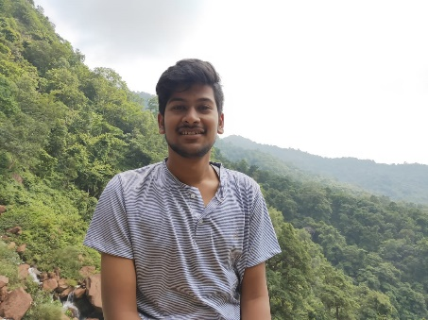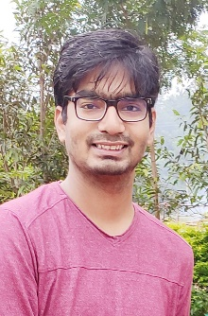**CORE TEAM**

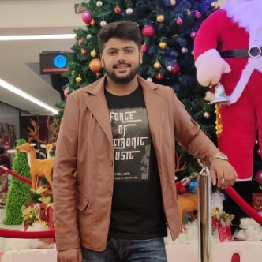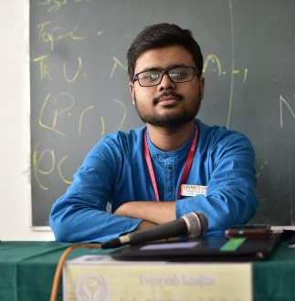

**Pratyush Ranjan Satyajit Raiguru Suman Acharya Jitamitra Sahu**

**President Vice President Secretary Treasurer**



**Shuvam Mohapatra**

**Team Head**

**Pratyush Ranjan**

Facebook : https://www.facebook.com/pratyush.ranjan.33483903

Instagram : https://www.instagram.com/pratyush11.05/?hl=en

**Suman Acharya**

Facebook : https://www.facebook.com/suman.acharya.543

Instagram : https://www.instagram.com/sumhack07/?hl=en

**Jitamitra Sahu**

Facebook : https://www.facebook.com/jitamitra.sahu

Instagram : https://instagram.com/jitamitra.sahu?igshid=lw46sip9f1a6

**Shuvam Mohapatra**

Facebook : <https://www.facebook.com/shuvam.mohapatra.56>

Instagram : <https://instagram.com/mr._.stra_nge?igshid=1y2errq2o4qp7>

**For Footer:**

[**https://www.facebook.com/sdgcampusclubnitrkl**](https://www.facebook.com/sdgcampusclubnitrkl) **- Facebook Handle**

[**https://www.instagram.com/sdgcampusclub_nitrkl/**](https://www.instagram.com/sdgcampusclub_nitrkl/) **- Instagram Handle**

1. 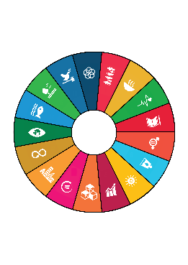About SDG Campus Club, NIT Rourkela

The inception of the SDG Campus Club was based on the theme of promoting the 17 Sustainable Development Goals of the United Nations and conducting events and seminars for raising awareness about them within the students and faculty. The SDGs encompass all aspects of societal development including – Environment Protection, alleviating poverty, promoting healthy lifestyle, Promoting Sustainable use of energy and maintaining proper hygiene, Women Empowerment, Education for all etc. and act as parameters for a developmental index. Being the first of its kind among the all other social service clubs on campus – this club would not just be limited to conducting direct events with NGOs and Governmental Organizations but also conducting conferences, seminars, marathons, awareness weeks, etc. in collaboration with other clubs under the society including of the likes conducted by the literary clubs.

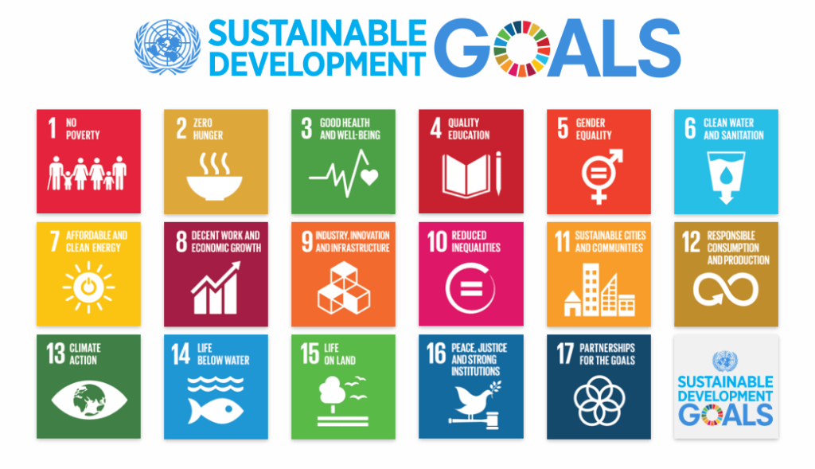

The Club is organizing the SDG International Film Festival of NIT Rourkela on 3rd and 4th of October. Please check the **International Film Festival** section for more details regarding the detailed itinerary including speakers and list of documentaries & short films to be screened in the festival.

1. About SDGs

The United Nations **Sustainable Development Goals** are the blueprint to achieve a better and more sustainable future for all.

Refer the Booklet on SDGs for Remaining Content in this section

1. SDG International Film Festival

The SDG International Film Festival aims to bridge the gap between policy makers, civil society, non-profits and the youth. Through the 2-day festival which would involve **online screening of award-winning documentaries and short films** based on the various SDG thematic areas as well as **pre-conference talk series with various experts,** we hope to make it an enriching experience for both the participants and other stakeholders.

The screening of the short films shall also be followed by a **live interaction with the directors and actors of the documentaries who would provide a short keynote on the inspiration behind making the short film followed by a question and answer session with the audience.**

Short Films and Feature Documentaries

(To be screened at the Film Festival)

1. Create 2030 (<https://www.youtube.com/watch?v=ROzXn5ldwxc&list=PLpr1sw3X4GPDFopSzV9Y9zYIGvJq6CyiF&index=4>)

Create2030 is a new advocacy video and creative campaign to engage artists and storytellers in meeting the #SDGs. Can artists help to change the world? #Create2030 thinks so. Directed by Emmy-winning filmmaker, Lisa Russell.



1. Sayang Kalimantan

(<https://www.youtube.com/watch?v=vVMHO6VpcjU&feature=youtu.be&list=PLEXw1ZgSf5_pBhwZL2gPB3Kd2r6QKHbrD>)

This short film from Wally Tham of Singapore documents how the filmmaker and his colleagues spent two years designing and building Indonesia’s first functioning haze shelter in the town of Kalimantan.

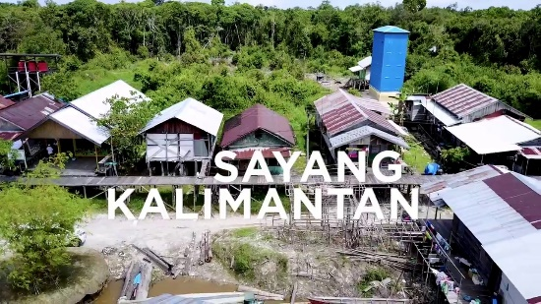

1. Protecting Our Planet: Aquastory

(<https://www.youtube.com/watch?v=fXjK7rd6cG0&ab_channel=LisboaE-Nova>)

The “Aquastory” Project (Aquametragem) was promoted by Lisboa E-Nova and consisted on the development, production and directing of a short animation film about the efficient use of water, for a broad dissemination to the general public.

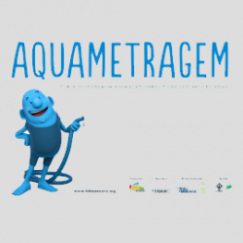

1. Sustainable Futures: Survivor Girls

Sustainable Futures: Survivor Girls documents the impact of a solar energy and water filtration system donated to a sex trafficking rescue shelter for underage girls in Kolkata, India.

1. Mr. Toilet: The World’s #2 Man

Jack Sim, aka "Mr. Toilet," is a crusader for global sanitation. Born in the Singapore slums, Sim knows firsthand the agonies of not having a proper loo. Now he's dedicating his life to a crisis no one dares talk about.

1. The Conductor

(<https://www.youtube.com/watch?v=pBx6JHvTjxM>)

Based in the U.K., filmmaker Bethany Borg created an animated world in which one man commits “citywide plant anarchy” to bring nature back to his urban environment.

1. Architecture, Life, Dialogue

(<https://www.youtube.com/watch?v=IUFadtDuRLM>)

An adventurous, philosophical, and fun film about serious topics: sustainability, sharing economy, food waste, conscious consumption, and the principles of sustainable architecture.



Speakers & Guests

1. Lisa Russells

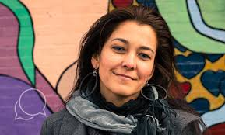

Ms. Lisa Russell is an Emmy Award-winning filmmaker and Founder of Create2030 who has 15+ years experience producing films and creative events across the globe for leading UN/NGO agencies. An established global speaker and thought leader, Lisa is a two time TEDx speaker, SheDecides Global Champion, UN/NGO contracted storyteller and arts curator and Fulbright Specialist.

1. Wally Tham



Meet Mr. Wally Tham from Singapore, Director of “Sayang Kalimantan”. He is an Organisational Development practitioner as well as an award winning media producer. He also serves as the Director of Big Red Button Organization.How the filmmaker and his colleagues spent two years designing and building Indonesia’s first functioning haze shelter in the town of Kalimantan.

1. Diana Henriques

Ms. Diana Henriques is the Project Manager at Lisboa-E-Nova focusing on Education for Sustainable Development, Biodiversity, Climate Change, Circular Economy as well as citizen engagement and participatory activities. She has coordinated projects including Aquametragem / Aquastory (awarded within UN's SDGs in Action Film Festival in the Category "Protecting our planet).



1. Nicole Watson



Nicole shares her time between her non-profit program work and production of factual content in the film industry. Founder of ‘econic earth’ a 501(c)3 charitable organization based in California, she is dedicated to environmental and wildlife conservation initiatives while empowering students and communities with solar power.

1. Jack Sims



Globally known as Mr. Toilet, Mr. Sims is a Serial Entrepreneur with 16 businesses turned Serial Social Entrepreneur with 8 social businesses. He retired at the age of 40 to devote full time on changing the world. Mr. Sims had founded the Restroom Association of Singapore in 1998 and World Toilet Organisation in 2001. He is also accredited with Creating the UN World Toilet Day.

1. Inessa Kraft



Inessa Kraft is an actress, writer, and director. Sustainability, education, and connecting cultures are the main topics of her work and life. Inessa is focused on educational, travel, and inspirational films, videos, advertisements, and stories.  
  
Inessa was always interested in life, philosophy, and human nature. She discovered a book of Konstantin Stanislavski "An Actor prepares" and was amazed that the art of acting is not about pretending or "acting mechanically," but actually about living. After that she started studying performing arts.

Based on the message of her film Architecture Life Dialogue Inessa Kraft makes speeches and presentations showing how A - zero waste lifestyle and B - the sharing economy will bring us to the dance of lives between people and the world of AB-un-dance.

1. Bethany Borg



Bethany Borg is the Director of the short film “The Conductor” and is from the United Kingdom. She has a degree in Animation and Media from the University of Wolverhampton and has been a part of several projects in several capacities and film making is something she looks up to as a way of creating change in the world.

1. Webinars & Expert Talks



* **Ashley Maria**

**Topic:** Gender Equality : A Global Perspective

Ashley Maria is a director and writer located in Los Angeles, CA. She received her MFA from the [USC School of Cinematic Arts](https://cinema.usc.edu/), is the recipient of the prestigious Directors Guild of America award, and most recently, she was recognized as the “Best New Director” at the DTLA Film Festival.

Best known for her films and media work, including the comedy & horror shorts — Friday Night Fright and Volcano Girl, and her 2020 breakthrough production [Pioneers in Skirts](https://www.pioneersinskirts.com/), Ashley is also an advocate for advancing women’s opportunities. She is a North American delegate to the [United Nations Commission on the Status of Women](https://www.unwomen.org/en/csw) – the principal global policy-making body dedicated exclusively to gender equality and the advancement of women.

When not on set, Ashley is a directing instructor at UCLA’s Film School and a sound instructor at the American Film Institute’s Young Women in Film program.

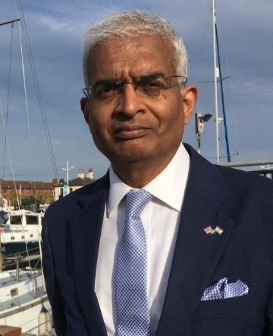

* **Sunil Murlidhar Shastri**

**Topic:** Ocean Governance and Blue Economy

Sunil Murlidhar Shastri is a consultant, expert and speaker in ocean and environmental governance. He found his passion for Pacem in Maribus in 1982 under the tutelage of Elisabeth Mann Borgese and has since made it his mission. He is best known internationally for his MasterClass and for his erudite analysis and candid opinions. Sunil has attended, at various times, the Indian Institute of Technology Kharagpur, International Ocean Institute, Aachen Technical University, Dalhousie University, London School of Economics and Harvard Kennedy School, supported throughout by prestigious scholarships. Sunil has previously been a university academic, consultant and researcher in marine and environmental policy, and in mining and ocean engineering. He has served on several professional and public bodies as member, governor or trustee and is a Rotary International Paul Harris Fellow. Sunil was born in India in 1955 and has lived in the UK since 1988 with his wife and son.

**6)** Partners

**Sponsors**

Farm to Fork Solutions



**Organizational Partners**

Phoenix Events & Entertainment

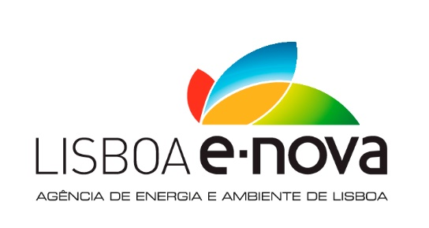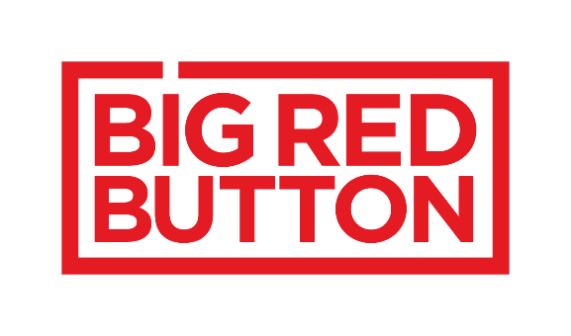

**Clubs & Student Bodies**

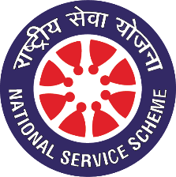

NSS NIT Rourkela

**7) FAQ & Contact**

FAQ (Take Inspiration from <https://nitrimun.org/FAQ.html>)

* What is the SDG International Virtual Film Festival all about and who is organizing it?

Ans. The SDG International Film Festival aims to bridge the gap between policy makers, civil society, non-profits and the youth. Through the 2-day festival which would involve **online screening of award-winning documentaries and short films** based on the various SDG thematic areas as well as **pre-conference talk series with various experts,** we hope to make it an enriching experience for both the participants and other stakeholders.

* Who can participate and what are the dates of the Film Festival?

Ans. Any School or College student is free to participate as a Delegate at the SDG International Film Festival. Working Professionals can also participate in the Festival by mentioning the name of their organization on the registration form.

* Is there a registration fee for attending the Film Festival? Also do I need to be a part of a college delegation to participate in the Film Festival?

Ans. No, the Film Festival is completely free to attend for anyone who is committed towards promotion of the United Nations Sustainable Development Goals. There are two modes of participation either as a part of an institutional delegation which needs to be communicated earlier to us through mail or by individual registration on the Google Form.

* What are the other benefits and perks of attending the Film Festival?

Ans. The Film Festival has 2 segments:

1. Pre & Post Festival Webinars and Expert Talks on individual SDG areas by Prominent Personalities.
2. The SDG Film Festival itself on 3rd and 4th October which would involve screening of award winning selected short documentaries and films on various SDG thematic areas. This shall also be followed by an address by each Documentary Director Live and Question and Answer session with the Delegates.

All registered delegates will receive prior communication to attend the Pre and Post Festival webinars apart from the Film Festival. Special Certificates shall be provided to Heads of Institutional Delegations and Participation Certificate to all registered Delegates of the Film Festival. A Post Festival speed networking session on zoom with all delegates is also expected to be organized by the Club.

* How to register for the Film Festival and take part?

Ans. You can register by filling the form at <https://bit.ly/2R4xr5l> or by clicking the Register Button on the website.

|  |
| --- |
| Reach out to us at:  MAKE A FORM (NAME, EMAIL ID, PHONE NUMBER, MESSAGE) |